**Εθνικό Μετσόβιο Πολυτεχνείο** 

**Σχολή Ηλεκτρολόγων Μηχανικών και Μηχανικών**

**Υπολογιστών**

Εξάμηνο: 8ο Ακ. Έτος: 2024- 2025

# «Ψηφιακά Συστήματα VLSI»

Χαράλαμπος Παπαδόπουλος (ΑΜ: 03120199)

Νικόλαος Παπακωνσταντόπουλος (ΑΜ: 03120069)

Ομάδα: 45

# Σχεδίαση Μονάδων Υλικού με την Τεχνική Pipelining

Ο σκοπός της παρούσας άσκησης είναι η υλοποίηση μονάδων υλικού (αθροιστή και συστολικού πολλαπλασιαστή) με χρήση της μεθόδου Pipelining. Σε αυτή την τεχνική, ο υπολογισμός του αποτελέσματος προκύπτει από συγκεκριμένο αριθμό σταδίων καθένα από τα οποία “πυροδοτείται” με μια ανερχόμενη ακμή ρολογιού. Συνεπώς, το επιθυμητό αποτέλεσμα παράγεται με συγκεκριμένη καθυστέρηση στην έξοδο, (σύνολο σταδίων του pipeline επί την περίοδο ρολογιού).

Προς τούτο, πρέπει να είναι σύγχρονες οι δομικές μονάδες των ψηφιακών κυκλωμάτων (σύγχρονες σημαίνει ότι ενημερώνουν το αποτέλεσμα σε κάθε ανερχόμενη ακμή ρολογιού). Παρατίθενται λοιπόν οι δομικές μονάδες του σύγχρονου αθροιστή, του D Flip Flop και του pipeline cell που χρησιμοποιείται για τον πολλαπλασιαστή.

### Synchronous Adder

library IEEE;

use IEEE.STD_LOGIC_1164.ALL;

entity sync_adder is

Port (A : in std_logic;

B : in std_logic;

Cin : in std_logic;

rst : in std_logic;

clk : in std_logic;

Sum : out std_logic;

Cout : out std_logic);

end sync_adder;

architecture Behavioral of sync_adder is

begin

process(clk, rst)

begin

if rst = '1' then

Sum <= '0';

Cout <= '0';

elsif rising_edge(clk) then

Sum <= A xor B xor Cin;

Cout <= (A and B) or (B and Cin) or (A and Cin);

end if;

end process;

end Behavioral;

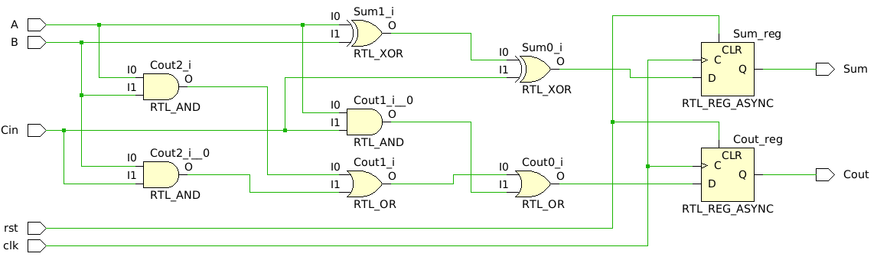

library IEEE;

use IEEE.STD_LOGIC_1164.ALL;

entity sync_adder_tb is

end sync_adder_tb;

architecture Behavioral of sync_adder_tb is

component sync_adder is

Port (A : in std_logic;

B : in std_logic;

Cin : in std_logic;

rst : in std_logic;

clk : in std_logic;

Sum : out std_logic;

Cout : out std_logic);

end component;

signal A, B, Cin, Sum, Cout : std_logic;

signal rst, clk : std_logic := '0';

begin

uut: sync_adder port map (

A => A,

B => B,

Cin => Cin,

rst => rst,

clk => clk,

Sum => Sum,

Cout => Cout

);

clk_proc: process begin

clk <= '0';

wait for 5 ns;

clk <= '1';

wait for 5 ns;

end process;

stim_proc: process begin

rst <= '1';

A <= '1';

B <= '1';

Cin <= '1';

wait for 10 ns;

rst <= '0';

A <= '1';

B <= '0';

Cin <= '0';

wait for 10 ns;

A <= '1';

B <= '1';

Cin <= '0';

wait for 10 ns;

A <= '1';

B <= '1';

Cin <= '1';

wait for 10 ns;

A <= '0';

B <= '0';

Cin <= '0';

wait for 10 ns;

A <= '0';

B <= '0';

Cin <= '1';

wait for 10 ns;

A <= '0';

B <= '1';

Cin <= '1';

wait for 10 ns;

A <= '1';

B <= '1';

Cin <= '1';

wait for 10 ns;

A <= '1';

B <= '0';

Cin <= '1';

wait for 10 ns;

A <= '0';

B <= '0';

Cin <= '0';

wait for 10 ns;

A <= '1';

B <= '1';

Cin <= '1';

wait for 10 ns;

rst <= '1';

wait;

end process;

end Behavioral;

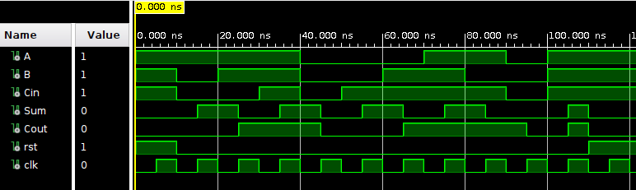

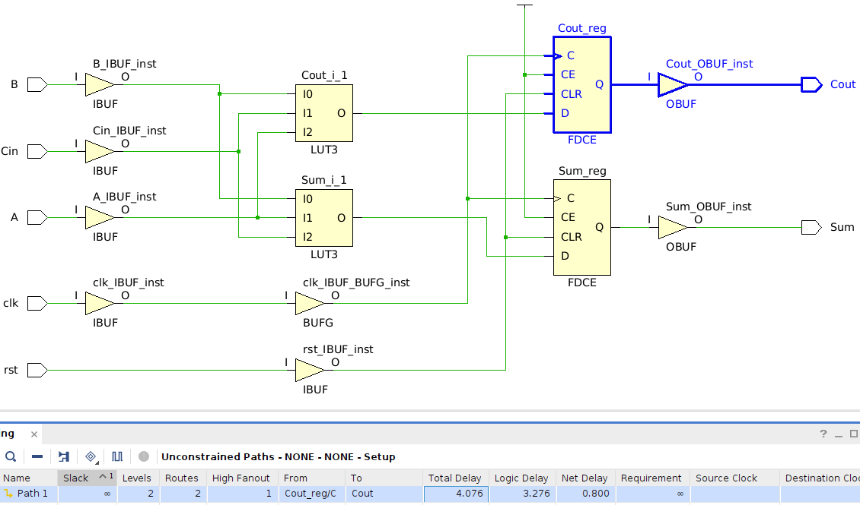

*Critical Path (D flip flop -> cout): 4.076 ns*

### D Flip Flop

Library IEEE;

USE IEEE.Std_logic_1164.all;

entity D_flip_flop is

port(

clk :in std_logic;

rst: in std_logic;

D :in std_logic;

Q : out std_logic

);

end D_flip_flop;

architecture Behavioral of D_flip_flop is

begin

process(clk,rst)

begin

if(rst='1') then

Q <= '0';

elsif(rising_edge(clk)) then

Q <= D;

end if;

end process;

end Behavioral;

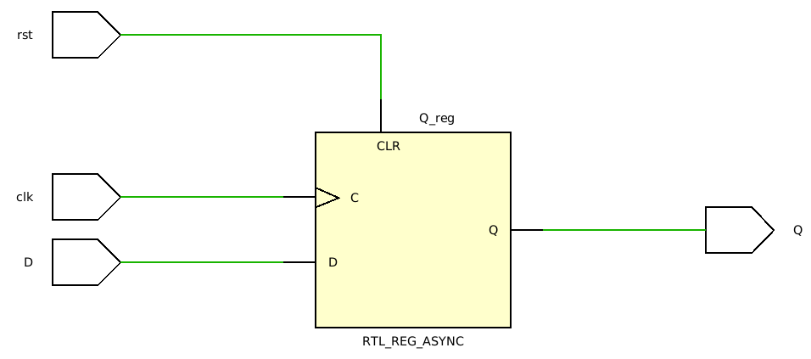

## Pipeline Adder

Pipeline adder

library IEEE;

use IEEE.STD_LOGIC_1164.ALL;

entity pipeline_adder is

Port (

A : in std_logic_vector(3 downto 0);

B : in std_logic_vector(3 downto 0);

cin : in std_logic;

cout : out std_logic;

sum : out std_logic_vector(3 downto 0);

clk : in std_logic;

rst : in std_logic

);

end pipeline_adder;

architecture Structural of pipeline_adder is

component sync_adder is

Port (A : in std_logic;

B : in std_logic;

Cin : in std_logic;

rst : in std_logic;

clk : in std_logic;

Sum : out std_logic;

Cout : out std_logic);

end component;

component D_flip_flop is

port(

clk :in std_logic;

rst: in std_logic;

D :in std_logic;

Q : out std_logic

);

end component;

signal stage1_cout, stage1_sum, stage2_cout, stage2_sum, stage3_cout, stage3_sum : std_logic;

signal stage1_D_A1, stage1_D_B1 : std_logic;

signal stage1_D_A2, stage1_D_B2, stage2_D_A2, stage2_D_B2 : std_logic;

signal stage1_D_A3, stage1_D_B3, stage2_D_A3, stage2_D_B3, stage3_D_A3, stage3_D_B3 : std_logic;

signal stage2_D0_out, stage3_D0_out : std_logic;

signal stage3_D1_out : std_logic;

begin

-- stage 1

stage1_FA: sync_adder port map(A => A(0), B => B(0), cin => cin, rst => rst, clk => clk, Sum => stage1_sum, Cout => stage1_cout);

stage1_DFF_A1: D_Flip_Flop port map(clk => clk, rst => rst, D => A(1), Q => stage1_D_A1);

stage1_DFF_B1: D_Flip_Flop port map(clk => clk, rst => rst, D => B(1), Q => stage1_D_B1);

stage1_DFF_A2: D_Flip_Flop port map(clk => clk, rst => rst, D => A(2), Q => stage1_D_A2);

stage1_DFF_B2: D_Flip_Flop port map(clk => clk, rst => rst, D => B(2), Q => stage1_D_B2);

stage1_DFF_A3: D_Flip_Flop port map(clk => clk, rst => rst, D => A(3), Q => stage1_D_A3);

stage1_DFF_B3: D_Flip_Flop port map(clk => clk, rst => rst, D => B(3), Q => stage1_D_B3);

-- stage 2

stage2_DFF_S0: D_Flip_Flop port map(clk => clk, rst => rst, D => stage1_sum, Q => stage2_D0_out);

stage2_FA: sync_adder port map(A => stage1_D_A1, B => stage1_D_B1, cin => stage1_cout, rst => rst, clk => clk, Sum => stage2_sum, Cout => stage2_cout);

stage2_DFF_A2: D_Flip_Flop port map(clk => clk, rst => rst, D => stage1_D_A2, Q => stage2_D_A2);

stage2_DFF_B2: D_Flip_Flop port map(clk => clk, rst => rst, D => stage1_D_B2, Q => stage2_D_B2);

stage2_DFF_A3: D_Flip_Flop port map(clk => clk, rst => rst, D => stage1_D_A3, Q => stage2_D_A3);

stage2_DFF_B3: D_Flip_Flop port map(clk => clk, rst => rst, D => stage1_D_B3, Q => stage2_D_B3);

-- stage 3

stage3_DFF_S0: D_Flip_Flop port map(clk => clk, rst => rst, D => stage2_D0_out, Q => stage3_D0_out);

stage3_DFF_S1: D_Flip_Flop port map(clk => clk, rst => rst, D => stage2_sum, Q => stage3_D1_out);

stage3_FA: sync_adder port map(A => stage2_D_A2, B => stage2_D_B2, cin => stage2_cout, rst => rst, clk => clk, Sum => stage3_sum, Cout => stage3_cout);

stage3_DFF_A3: D_Flip_Flop port map(clk => clk, rst => rst, D => stage2_D_A3, Q => stage3_D_A3);

stage3_DFF_B3: D_Flip_Flop port map(clk => clk, rst => rst, D => stage2_D_B3, Q => stage3_D_B3);

-- stage 4

stage4_DFF_S0: D_Flip_Flop port map(clk => clk, rst => rst, D => stage3_D0_out, Q => sum(0));

stage4_DFF_S1: D_Flip_Flop port map(clk => clk, rst => rst, D => stage3_D1_out, Q => sum(1));

stage4_DFF_S2: D_Flip_Flop port map(clk => clk, rst => rst, D => stage3_sum, Q => sum(2));

stage4_FA: sync_adder port map(A => stage3_D_A3, B => stage3_D_B3, cin => stage3_cout, rst => rst, clk => clk, Sum => sum(3), Cout => cout);

end Structural;

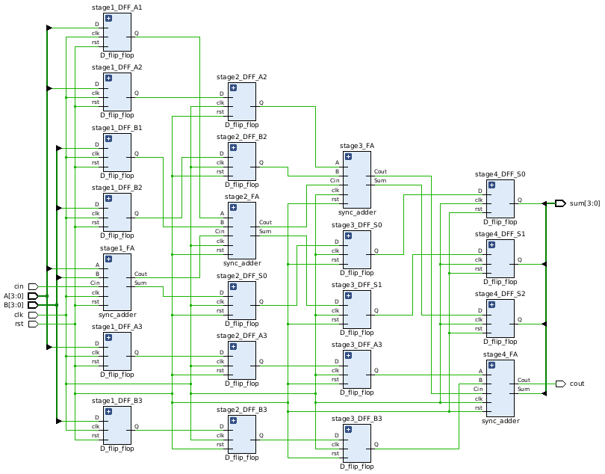

library IEEE;

use IEEE.STD_LOGIC_1164.ALL;

use IEEE.STD_LOGIC_UNSIGNED.ALL;

use STD.TEXTIO.ALL;

entity pipeline_adder_tb is

end pipeline_adder_tb;

architecture testbench of pipeline_adder_tb is

component pipeline_adder is

Port (

A : in std_logic_vector(3 downto 0);

B : in std_logic_vector(3 downto 0);

cin : in std_logic;

cout : out std_logic;

sum : out std_logic_vector(3 downto 0);

clk : in std_logic;

rst : in std_logic

);

end component;

signal A, B : std_logic_vector(3 downto 0);

signal cin, cout : std_logic;

signal sum : std_logic_vector(3 downto 0);

signal clk, rst : std_logic;

constant CLOCK_PERIOD : time := 10ns;

begin

UUT: pipeline_adder port map(

A => A,

B => B,

cin => cin,

cout => cout,

sum => sum,

clk => clk,

rst => rst

);

GEN_CLK : process

begin

clk <= '0';

wait for CLOCK_PERIOD/2;

clk <= '1';

wait for CLOCK_PERIOD/2;

end process;

STIMULUS: process

begin

-- use rst = 1 to reset the pipeline_adder

-- use rst = 0 to enable the pipeline_adder

rst <= '1';

wait for CLOCK_PERIOD;

rst <= '0';

wait for CLOCK_PERIOD;

-- now 2 periods have passed, so we can start testing

-- test case 1: 5 + 10 = 15

A <= "0101"; B <= "1010"; cin <= '0';

wait for CLOCK_PERIOD;

-- test case 2: 3 + 7 + 1 = 11

A <= "0011"; B <= "0111"; cin <= '1';

wait for CLOCK_PERIOD;

-- test case 3: 12 + 15 = 27 (11)

A <= "1100"; B <= "1111"; cin <= '0';

wait for CLOCK_PERIOD;

-- test case 4: 15 + 15 + 1 = 31 (15)

A <= "1111"; B <= "1111"; cin <= '1';

wait for CLOCK_PERIOD;

wait;

end process;

assertions: process

begin

wait for 2*CLOCK_PERIOD; -- reset time

wait for 4*CLOCK_PERIOD; -- 4 stages of pipeline

assert sum = "1111" and cout = '0'

report "Test case 1 failed (5 + 10 = 15)"

severity error;

wait for CLOCK_PERIOD;

assert sum = "1011" and cout = '0'

report "Test case 2 failed (3 + 7 + 1 = 11)"

severity error;

wait for CLOCK_PERIOD;

assert sum = "1011" and cout = '1'

report "Test case 3 failed (12 + 15 = 27 (11))"

severity error;

wait for CLOCK_PERIOD;

assert sum = "1111" and cout = '1'

report "Test case 4 failed (15 + 15 + 1 = 31 (15))"

severity error;

wait for CLOCK_PERIOD;

wait;

end process;

end testbench;

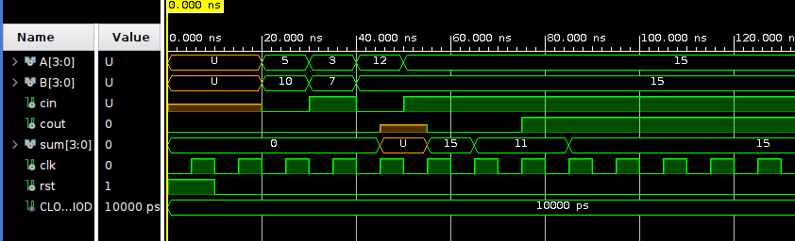

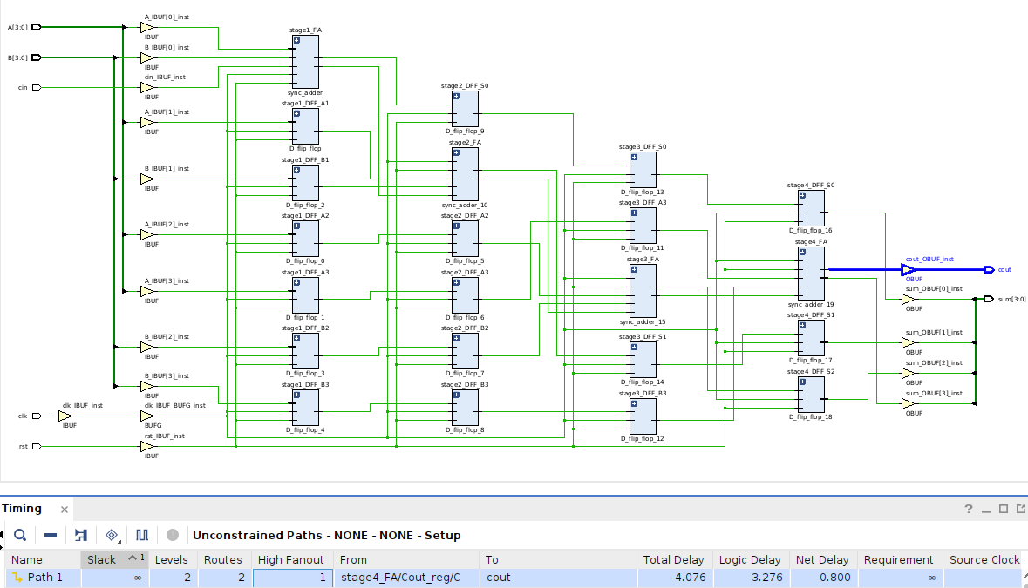

*Critical Path (Stage 4 full adder -> cout): 4.076 ns*

## Systolic Multiplier

### Pipeline cell for multiplier

library IEEE;

use IEEE.STD_LOGIC_1164.ALL;

entity pipeline_cell is

Port (

A : in std_logic;

B : in std_logic;

cin : in std_logic;

sin : in std_logic;

cout : out std_logic;

sout : out std_logic;

clk : in std_logic;

rst : in std_logic

);

end pipeline_cell;

architecture structural of pipeline_cell is

component sync_adder is

Port (A : in std_logic;

B : in std_logic;

Cin : in std_logic;

rst : in std_logic;

clk : in std_logic;

Sum : out std_logic;

Cout : out std_logic);

end component;

signal tmp : std_logic;

begin

tmp <= A AND B;

fa: sync_adder

port map (

A => tmp,

B => sin,

cin => cin,

rst => rst,

clk => clk,

sum => sout,

cout => cout

);

end structural;

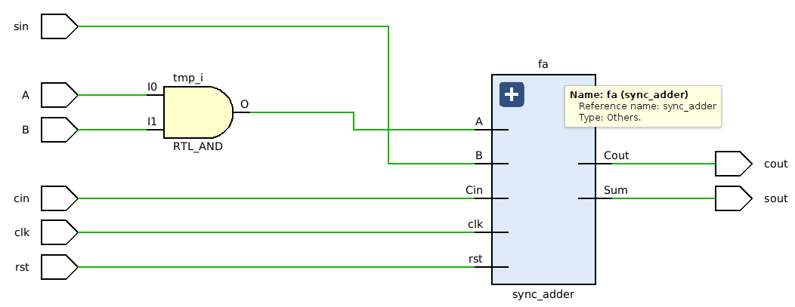

### Systolic Multiplier Entity and Architecture Definition

library IEEE;

use IEEE.STD_LOGIC_1164.ALL;

use IEEE.STD_LOGIC_UNSIGNED.ALL;

entity systolic_multiplier is

Port (

A : in STD_LOGIC_VECTOR(3 downto 0);

B : in STD_LOGIC_VECTOR(3 downto 0);

P : out STD_LOGIC_VECTOR(7 downto 0);

clk : in STD_LOGIC;

rst : in STD_LOGIC

);

end systolic_multiplier;

architecture structural of systolic_multiplier is

component pipeline_cell is

Port (

A : in std_logic;

B : in std_logic;

cin : in std_logic;

sin : in std_logic;

cout : out std_logic;

sout : out std_logic;

clk : in std_logic;

rst : in std_logic

);

end component;

signal r0 : STD_LOGIC_VECTOR(8-1 downto 0); -- input register

signal r1, r2, r3 : STD_LOGIC_VECTOR(9-1 downto 0);

signal r4 : STD_LOGIC_VECTOR(10-1 downto 0);

signal r5, r6 : STD_LOGIC_VECTOR(9-1 downto 0);

signal r7 : STD_LOGIC_VECTOR(7-1 downto 0);

signal r8 : STD_LOGIC_VECTOR(8-1 downto 0);

signal r9 : STD_LOGIC_VECTOR(6-1 downto 0); -- output register

type matrix_4x4 is array (0 to 3, 0 to 3) of std_logic;

signal carrys : matrix_4x4;

type matrix_3x3 is array (0 to 3, 0 to 3) of std_logic;

signal sum : matrix_3x3;

signal p0,p1,p2,p3,p4,p5,p6,p7 : std_logic;

begin

pc00: pipeline_cell

port map(A => A(0), B => B(0), cin => '0', sin => '0', cout => carrys(0, 0), sout => p0, clk => clk, rst => rst);

pc01: pipeline_cell

port map(A => r0(1), B => r0(4), cin => carrys(0, 0), sin => '0', cout => carrys(0, 1), sout => sum(0, 1), clk => clk, rst => rst);

pc02: pipeline_cell

port map(A => r1(2), B => r1(4), cin => carrys(0, 1), sin => '0', cout => carrys(0, 2), sout => sum(0, 2), clk => clk, rst => rst);

pc03: pipeline_cell

port map(A => r2(3), B => r2(4), cin => carrys(0, 2), sin => '0', cout => carrys(0, 3), sout => sum(0, 3), clk => clk, rst => rst);

pc10: pipeline_cell

port map(A => r1(0), B => r1(5), cin => '0', sin => sum(0, 1), cout => carrys(1, 0), sout => p1, clk => clk, rst => rst);

pc11: pipeline_cell

port map(A => r2(1), B => r2(5), cin => carrys(1, 0), sin => sum(0, 2), cout => carrys(1, 1), sout => sum(1, 1), clk => clk, rst => rst);

pc12: pipeline_cell

port map(A => r3(2), B => r3(4), cin => carrys(1, 1), sin => sum(0, 3), cout => carrys(1, 2), sout => sum(1, 2), clk => clk, rst => rst);

pc13: pipeline_cell

port map(A => r4(3), B => r4(4), cin => carrys(1, 2), sin => r4(9), cout => carrys(1, 3), sout => sum(1, 3), clk => clk, rst => rst);

pc20: pipeline_cell

port map(A => r3(0), B => r3(5), cin => '0', sin => sum(1, 1), cout => carrys(2, 0), sout => p2, clk => clk, rst => rst);

pc21: pipeline_cell

port map(A => r4(1), B => r4(5), cin => carrys(2, 0), sin => sum(1, 2), cout => carrys(2, 1), sout => sum(2, 1), clk => clk, rst => rst);

pc22: pipeline_cell

port map(A => r5(2), B => r5(4), cin => carrys(2, 1), sin => sum(1, 3), cout => carrys(2, 2), sout => sum(2, 2), clk => clk, rst => rst);

pc23: pipeline_cell

port map(A => r6(2), B => r6(3), cin => carrys(2, 2), sin => r6(8), cout => carrys(2, 3), sout => sum(2, 3), clk => clk, rst => rst);

pc30: pipeline_cell

port map(A => r5(0), B => r5(5), cin => '0', sin => sum(2, 1), cout => carrys(3, 0), sout => p3, clk => clk, rst => rst);

pc31: pipeline_cell

port map(A => r6(0), B => r6(4), cin => carrys(3, 0), sin => sum(2, 2), cout => carrys(3, 1), sout => p4, clk => clk, rst => rst);

pc32: pipeline_cell

port map(A => r7(0), B => r7(2), cin => carrys(3, 1), sin => sum(2, 3), cout => carrys(3,2), sout => p5, clk => clk, rst => rst);

pc33: pipeline_cell

port map(A => r8(0), B => r8(1), cin => carrys(3,2), sin => r8(7), cout => p7, sout => p6, clk => clk, rst => rst);

next_clk : process(clk)

begin

if rising_edge(clk) then

r9 <= p5 & r8(6 downto 2);

r8 <= carrys(2, 3) & p4 & r7(6 downto 1);

r7 <= p3 & r6(7 downto 4) & r6(2 downto 1);

r6 <= carrys(1, 3) & r5(8 downto 1);

r5 <= p2 & r4(8 downto 5) & r4(3 downto 0);

r4 <= carrys(0, 3) & r3(8 downto 0);

r3 <= p1 & r2(8 downto 5) & r2(3 downto 0);

r2 <= r1(8 downto 0);

r1 <= p0 & r0(7 downto 0);

r0 <= B(3 downto 0) & A(3 downto 0);

end if;

P <= p7 & p6 & r9(5 downto 0);

end process;

end structural;

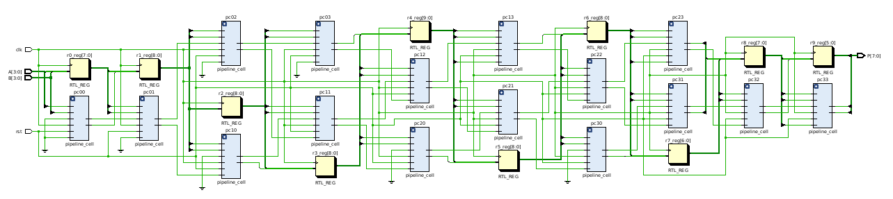

όπου τα κίτρινα κουτιά αναπαριστούν D Flip Flops ενώ τα μπλε pipeline cells

library IEEE;

use IEEE.STD_LOGIC_1164.ALL;

use IEEE.STD_LOGIC_UNSIGNED.ALL;

use STD.TEXTIO.ALL;

entity systolic_multiplier_tb is

end systolic_multiplier_tb;

architecture test of systolic_multiplier_tb is

component systolic_multiplier

port (

A: in std_logic_vector (3 downto 0);

B: in std_logic_vector (3 downto 0);

clk: in std_logic;

rst: in std_logic;

P: out std_logic_vector (7 downto 0)

);

end component;

signal A, B : std_logic_vector (3 downto 0):= (others=>'0');

signal clk, rst : std_logic:='0';

signal P : std_logic_vector(7 downto 0);

constant CLOCK_PERIOD : time := 10ns;

begin

UUT: systolic_multiplier port map(

A => A,

B => B,

clk => clk,

rst => rst,

P => P (7 downto 0)

);

GEN_CLK : process

begin

clk <= '0';

wait for CLOCK_PERIOD/2;

clk <= '1';

wait for CLOCK_PERIOD/2;

end process;

STIMULUS: process

begin

-- Test case 1: 5 * 10 = 50

A <= "0101";

B <= "1010";

wait for CLOCK_PERIOD;

-- Test case 2: 2 * 4 = 8

A <= "0010";

B <= "0100";

wait for CLOCK_PERIOD;

-- Test case 3: 12 * 15 = 180

A <= "1100";

B <= "1111";

wait for CLOCK_PERIOD;

-- Test case 5: 15 * 15 = 225

A <= "1111";

B <= "1111";

wait for CLOCK_PERIOD;

-- Test case 6: 1 * 1 = 1

A <= "0001";

B <= "0001";

wait for CLOCK_PERIOD;

-- Test case 7: 5 * 12 = 60

A<="0101";

B<="1100";

wait for CLOCK_PERIOD;

-- Test case 8: 6 * 6 = 36

A<="0110";

B<="0110";

wait for CLOCK_PERIOD;

-- Test case 9: 0 * 15 = 0

A<="0000";

B<="1111";

wait for CLOCK_PERIOD;

-- Test case 10: 4 * 7 = 28

A<="0100";

B<="0111";

wait for CLOCK_PERIOD;

A<="0000";

B<="0000";

wait;

end process;

assertions: process

begin

wait for 11 * CLOCK_PERIOD;

assert P = "00110010"

report "Test case 1 failed: 5 * 10 expected 50 (00110010)"

severity error;

-- Test case 2: 2 * 4 = 8

wait for CLOCK_PERIOD;

assert P = "00001000"

report "Test case 2 failed: 2 * 4 expected 8 (00001000)"

severity error;

-- Test case 3: 12 * 15 = 180

wait for CLOCK_PERIOD;

assert P = "10110100"

report "Test case 3 failed: 12 * 15 expected 180 (10110100)"

severity error;

-- Test case 5: 15 * 15 = 225

wait for CLOCK_PERIOD;

assert P = "11100001"

report "Test case 5 failed: 15 * 15 expected 225 (11100001)"

severity error;

-- Test case 6: 1 * 1 = 1

wait for CLOCK_PERIOD;

assert P = "00000001"

report "Test case 6 failed: 1 * 1 expected 1 (00000001)"

severity error;

-- Test case 7: 5 * 12 = 60

wait for CLOCK_PERIOD;

assert P = "00111100"

report "Test case 7 failed: 5 * 12 expected 60 (00111100)"

severity error;

-- Test case 8: 6 * 6 = 36

wait for CLOCK_PERIOD;

assert P = "00100100"

report "Test case 8 failed: 6 * 6 expected 36 (00100100)"

severity error;

-- Test case 9: 0 * 15 = 0

wait for CLOCK_PERIOD;

assert P = "00000000"

report "Test case 9 failed: 0 * 15 expected 0 (00000000)"

severity error;

-- Test case 10: 4 * 7 = 28

wait for CLOCK_PERIOD;

assert P = "00011101"

report "Test case 10 failed: 4 * 7 expected 28 (00011100)"

severity error;

report "Finished Tests";

wait;

end process;

end test;

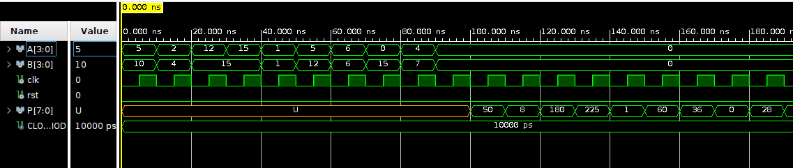

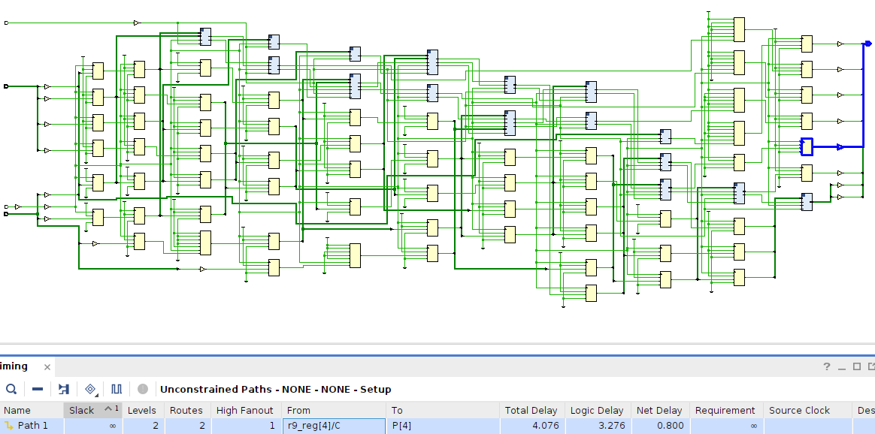

*Critical Path (Last Stage D Flip Flop -> P - out): 4.076 ns*